# IAM

# S3

### General

#### S3 does not require a Region selection. By default it will display as ‘global’

#### But when you create a bucket you have to select the region

### Bucket Name

#### Bucket name should be unique. Though you do not have the same bucket name, if someone has the same bucket name, then S3 will

### Access

#### If you upload a file in ‘Block public’ mode, then try to access by clicking the object URL as mentioned below it will throw error

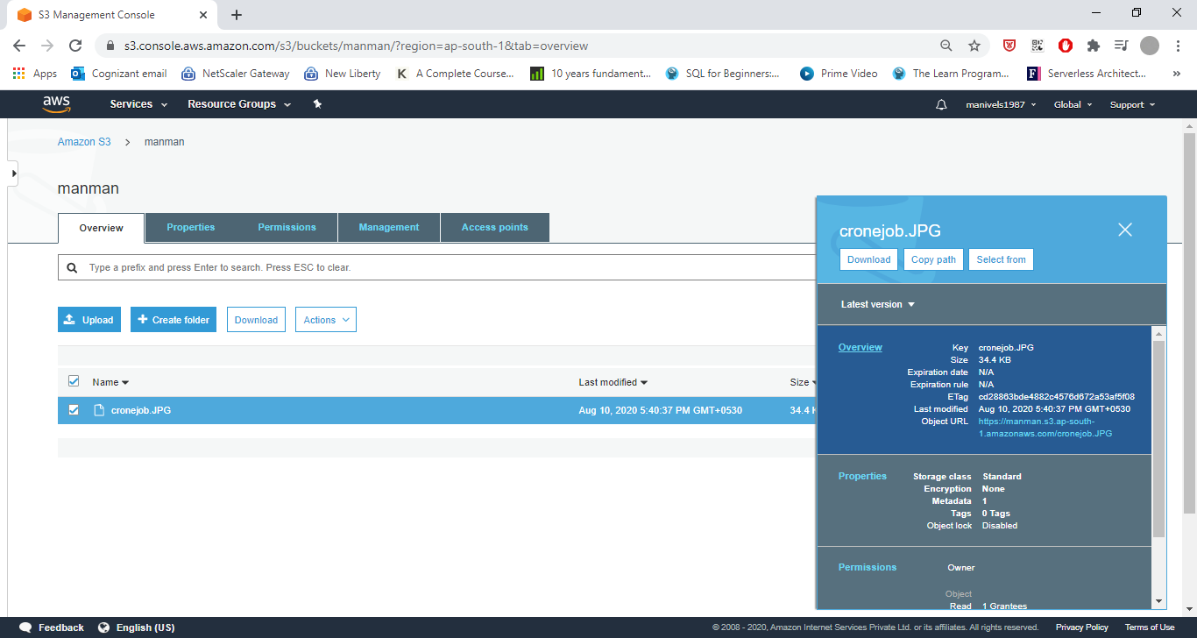

Error: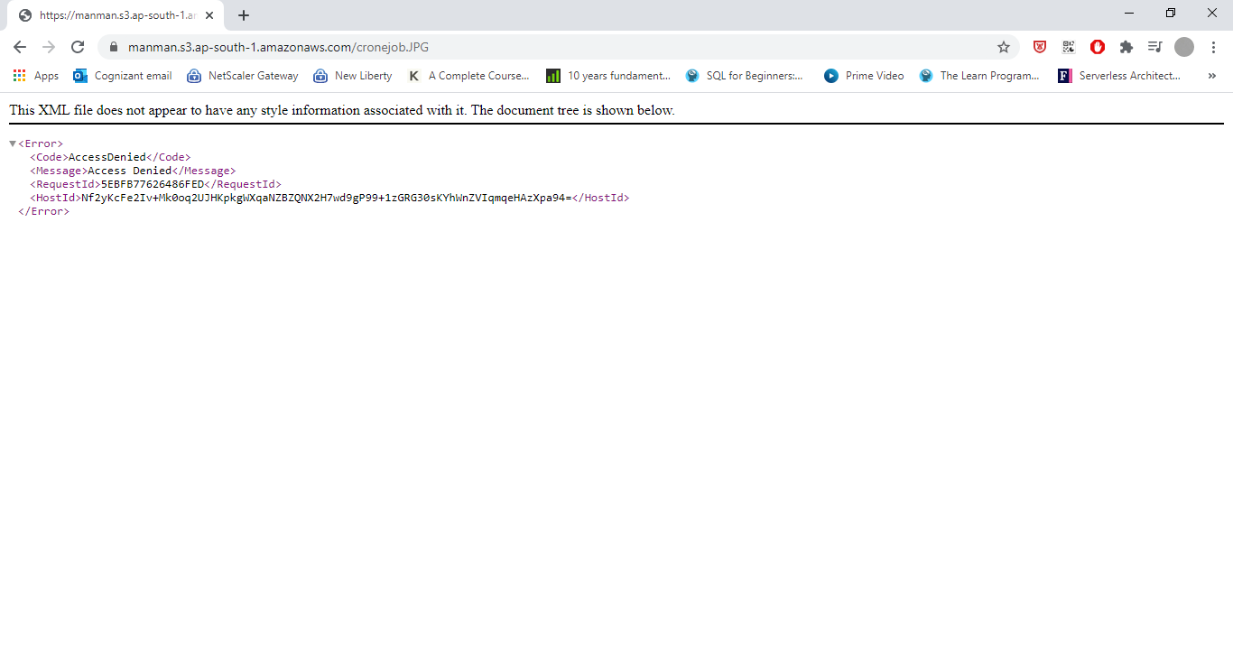

### S3 Versioning

#### Go to S3 console

#### Click on a bucket -> Properties

#### Click on ‘Versioning’

#### Click ‘Enable Versioning’

#### Click Overview again. Now see the ‘Option called – Version’.

#### Click ‘Show’

#### The image uploaded before enabling the versioning – has the version id as ‘Null’

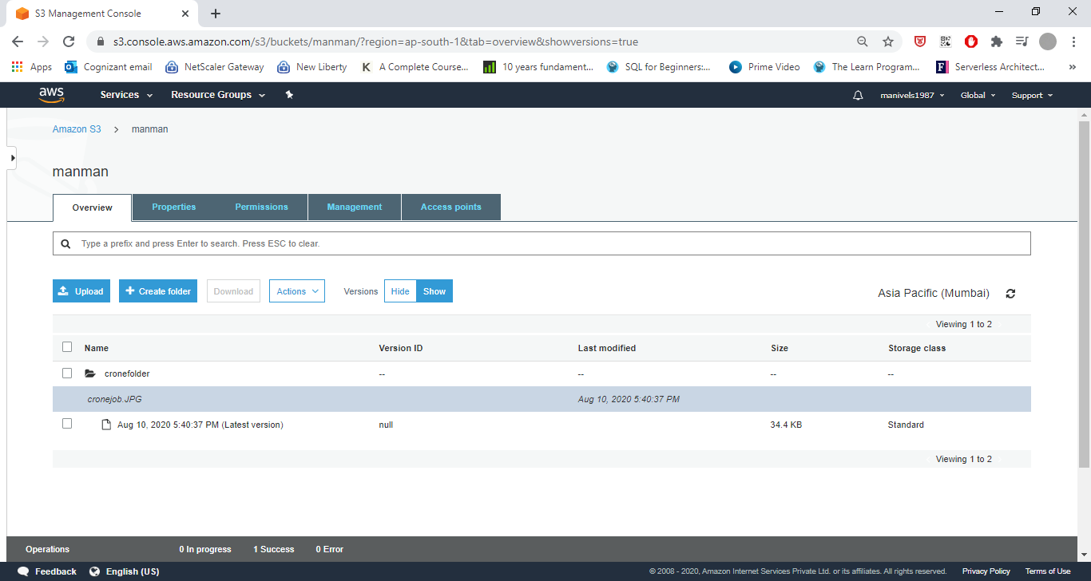

### Note:

#### When versioning is enabled, each time we do a modification in the file, version is created

#### If we delete the file, a new version (delete marker) is created for the delete event

#### We can delete that ‘delete marker’ version and make the next one as latest version anytime

#### Also we can delete any version from S3

### Suspending the versioning

#### We can suspend the versioning at any point of time.